**GALLERY**

**GALLERY OF PROTOTYPES ENGINEERING TEACHING AND RESEARCH EQUIPMENT SYSTEMS**

## IMTPROCESS-HEAT-TRANSFER APPARATUS

**by**

## Aghauche Ogbu, Samuel Uruabali, George Ogbonna, Thaddeus Omoti, Henry Menkiti, Christian Odogwu, Jude Omego, Cordelia Umeaku, Henry Ibe, Amaechi Nwogbe, Bright Onwukwe, Taiye Uzzi,

**and**

## George C. Oguejiofor Department of Chemical Engineering,

**I.M.T, Enugu**

## ABSTRACT

In challenging the lack of equipment for engineering education, the IMT Process-Heat-Transfer Apparatus was developed. The prototype development entailed mechanical workshop process for heat exchanger fabrication; glass blowing process for manometer construction; wood work process for bench construction; fitting process for centrifugal pumps, watertanks, electric thermostat water heaters, switches, rotameters, and differential manometers; plumbing process for cold and hot water channels; tubing process for manometer ducts; and wiring process for the centrifugal pumps and electric heaters via the switches. The photograph of the completed prototype was enclosed below and the prototype was found usable in Nigeria’s tertiary institutions of learning. The prototype IMT Process-Heat-Transfer Apparatus was exhibited in 1990 International Trade Fair held in Enugu where it earned the recognition of the panelists of FOPCIT (Foundation for the Promotion and Commercialisation of Indigenous Technology). Subsequently, the article about the prototype was invited for publication and documentation by the FOPCIT’s panelists.

## APPENDIX

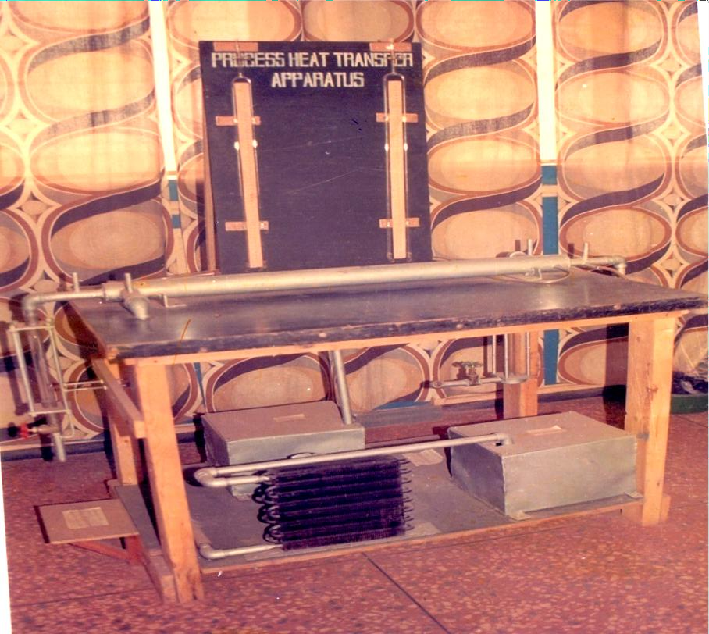

**Figure A-1: The photograph of front view of the prototype Apparatus after assembly**

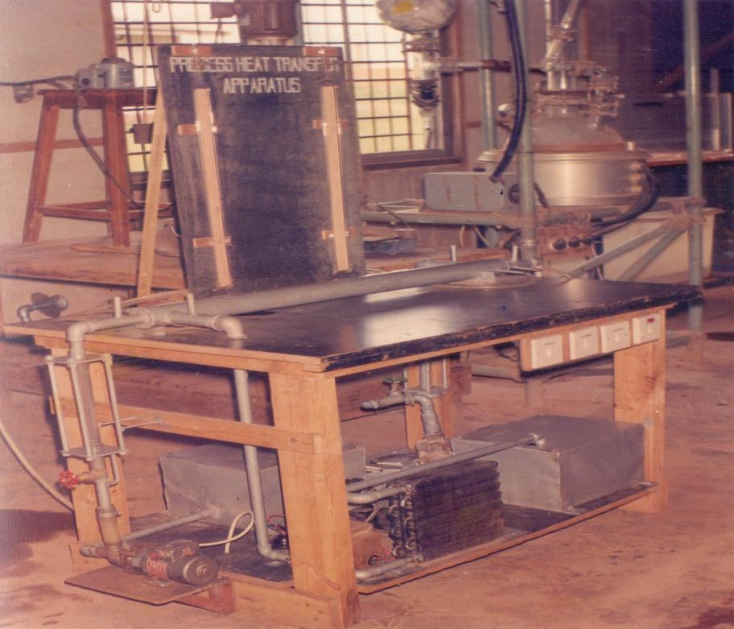

## Figure A-2: The photograph of diagonal view of the prototype Apparatus after electrical wiring and commissioning

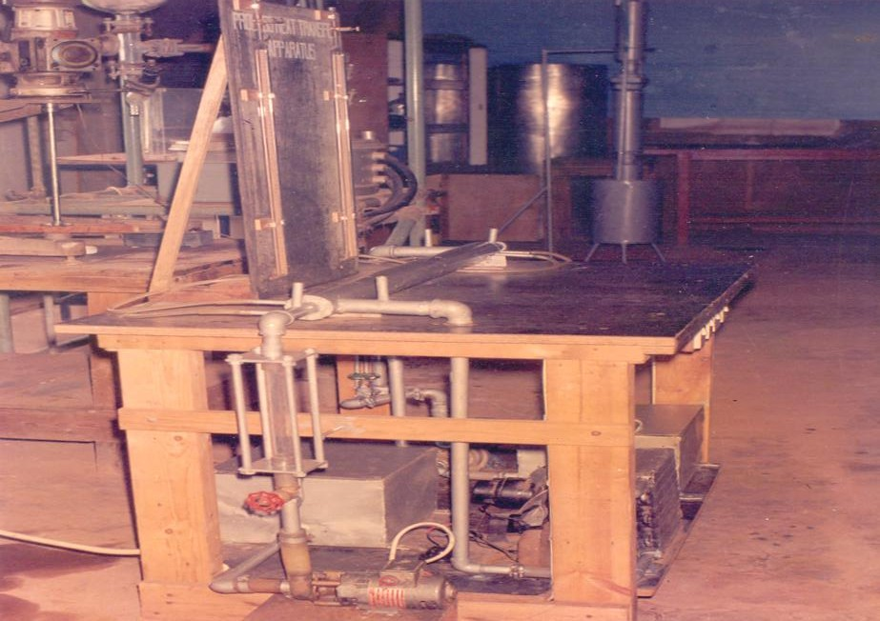

**Figure A-3: The photograph of side view of the prototype Appratus after electrical wiring and commissioning**

## IMTAIR-INDUCED PILOT-SCALE FLUIDISATION AND ELUTRIATION APPARATUS

**by**

## Anthony Ezekwem, Matthew Idoko, Christian Anidiobi, Gloria Eneh, Ogbonna Njasi, Okechukwu Uchenyi, Boniface Udeh,

**and**

## George C. Oguejiofor

## Department of Chemical Engineering,

**I.M.T., Enugu**

**ABSTRACT**

The IMT Fluidisation-And-Elutriation Apparatus was developed to reduce passive classroom learning and ensure active laboratory learning in tertiary institutions of learning in Nigeria. The development involved mechanical workshop process; glass-blowing workshop process; carpentry process for wooden bench and instrument panel construction; installation process for air blower, air cyclone separator, fluidisation/elutriation column, particulate-feed hopper, venturi-feed intake and differential manometer on the wooden bench; plumbing process for linkages; tubing process for appropriate connections; and electrical wiring process for the full actualisation of the prototype. The prototype photograph was enclosed below. The prototype IMT Fluidisation-And Elutriation Apparatus was exhibited at the 1990 International Trade Fair, Enugu, where it attracted the attention of FOPCIT panelists. Subsequently, the paper about the prototype was invited for publication and documentation by the FOPCIT’s panelists.

## APPENDIX

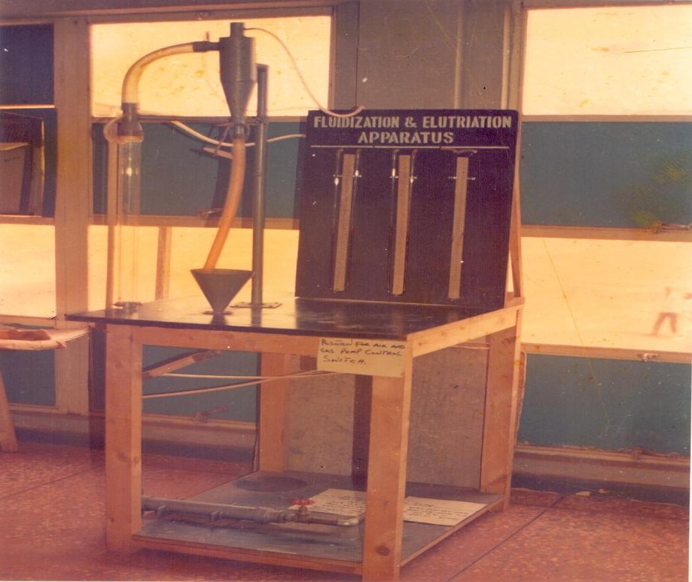

**FigureB-1:The photograph of front view of the prototype Apparatus after assembly**

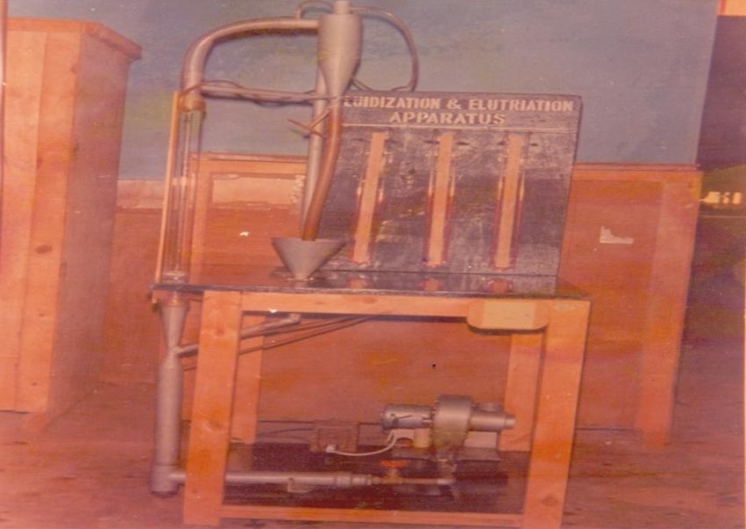

## FigureB-2:The photograph of front view of the prototype Apparatus after electrical wiring and commissioning

**DEVELOPMENT OF PROTOTYPE MULTIPLE PROCESS HEAT TRANSFER TRAINER**

**By**

**OGUEJIOFOR George C. ILO Ugochukwu V.**

**ONUKWULI Okechukwu D. Department of Industrial & Production Engineering**

**UMEMBAMALU, Chinedu Nnamdi Azikiwe University**

**UZUEGBUNAM Emmanuel N . Awka**

**Department of Chemical Engineering**

**Nnamdi Azikiwe University Awka**

**Correspondences to:**

[**Email:oguejioforg@yahoo.com**](mailto:oguejioforg@yahoo.com), **o**[**guejiofor.chiedozie@gmail.com**](mailto:guejiofor.chiedozie@gmail.com)

**Phone:+234 (0)8035500882**

## ABSTRACT

In an attempt to redress the deficit in engineering teaching and research equipment in Nigeria; and also to increase the understanding of engineering class room poetry by means of engineering laboratory practicals, the prototype multiple process heat transfer trainer was developed. The development was approached from chemical engineering principles and engineering craftsmanship. The development process which was at bench scale progressed through several phases involving the production of engineering working drawing; mechanical fabrication of components; purchase of auxiliaries, instruments and fixtures; assembling of components and auxiliaries; pipelining, instrumentation and tubing; and electrical fitting/wiring. The mechanical fabrication of two separate 1-1 and 1-2 shell-and-tube heat exchangers were undertaken and they were subsequently mounted on steel bench, previously constructed. A hot water tank fitted with four thermostat water heaters, a centrifugal pump for hot water, a cold water tank, a centrifugal pump for cold water, a trombone cooler (radiator) fitted with cooling fans were mounted on the steel bench. The pipelining consisted of the tube-side and the shell-side channels. The tube-side channel connected the hot-water tank, centrifugal pump, rotmeter, thermometer wells and heat exchangers’ tube-sides into the hot-water circuit. Also, the tube-side channel was pipelined for co-current and counter-current flow sequences by a network of pipe configurations interconnected with flow passage/isolation valves in between the heat exchangers. The shell-side channel pipelined the cold-water tank, centrifugal pump, rotameter, thermometer wells, heat exchangers’ shell sides, and trombone cooler into cold-water circuit. Electronic manometers and water-differential manometers were fitted and linked through manifolds to pressure tapping points on the heat exchangers’ hot-water and cold-water circuits by flexible tubings. The instrumentation was fully realised with manometers, rotameters and thermometer wells’ provisions. Electrical fitting and wiring were accomplished by fixing of assorted switches for electric heaters, centrifugal pumps and cooling fans; wiring with appropriate cables; and connection to the mains. The result from development process was a huge success which produced an Iconic prototype multiple process heat transfer trainer (see prototype photograph) deployable for engineering pedagogy and research in the subject area of process heat transfer. The prototype has the potentials of actualising practical learning on heat and mass balances over co-current, counter-current and cross-current heat exchangers; as well as dimensionless approach to process heat transfer evaluation; pinch analysis and pressure drop correlations for heat exchangers. Also, the prototype has the potentials for foreign exchange savings on equivalent equipment importation and enhancing the quest of Nigerian universities for global status.

Keywords: engineering-classroom poetry, chemical-engineering

principles, engineering craftsmanship, shell-and-tube-heat exchangers, heat-and-mass balances, pinch analysis, foreign-exchange savings.

## EQUIPMENT DESCRIPTION

The multiple process heat transfer trainer is designed as self-contained and self-dependent module, in which all the components are mounted on as a steel bench, with swivel rollers to ensure mobility. Mounted on the bench are 1-1 heat exchanger (single pass for both hot and cold fluids); 1-2 heat exchanger (single pass for the hot fluid and double pass for the cold fluid); radiator (air-cooled heat exchanger with double fan; hot water sump tank with four heating elements; coldwater sump tank; instrumentation panel harbouring a differential manometer, a set of digital manometer as a complement/alternative and two manometer manifolds; a network of pipes for hot and cold fluids circulation incorporating ball valves, thermo-wells, digital rotameters, orifices, pressure tapping points; eight on-off switches for the pumps, fans and heating elements as the enclosed photograph shows.

## TEACHING AND RESEARCH CAPABILITIES

With the features described above, the following experimental investigation scan be accomplished on the process heat transfer trainer:

* Heat transfer evaluation in shell-and-tube heat exchanger with co-current flow sequences.
* Heat transfer evaluation in shell-and-tube heat exchanger with counter-current flow sequences.
* Heat transfer evaluation in radiator with air-water cross flow sequences.
* Pressure drop across hell-and-tube heat exchanger with co-current and counter-current flow arrangement.

However, there search topic predicated is: software approach top inch analysis using home-grown multiple process heat transfer trainer.

## DEPLOYMENT AND COMMERCIALISATION POTENTIAL

Heat exchangers have widespread applications in all kinds of transportation vehicles, examples passengers and goods transporting vehicles, food processing industries, examples sugar plants and breweries; chemical process industries, examples petroleum refineries and petrochemical plants; and transformer stations in the electric power transmission systems. As an illustration, in the brewery hotwort from the brew kettle/mashtun is required to be cooled to about 4oC before admission into the fermentation cellars where yeast from the yeast propagation plant is added to breakdown the wort (soluble sugars) into alcohol, water and energy in the form heat. Though plate type of heat exchanger are used in the brewery, however, shell-and-tube heat exchangers made of aluminum and with multiple passes could be adapted in the brewery.

## POSSIBLE INVESTORS

Because the multiple process heat transfer trainer is basically a teaching and research equipment, the possible investors are universities, polytechnics and technical colleges of education. Because of its versatility other potential investors are the R&D units of the NNPC for downstream petroleum processing, Dangote Sugar Plants, Breweries, Electric Power Distribution Companies, and the R&D units of vehicle manufacturing/assembly plants to mention a few. Also Science Equipment Development Institute, SEDI and National Office for Technology Acquisition and Promotion, NOTAP could catalyse or enhance investors’ take-up.

# APPENDIX

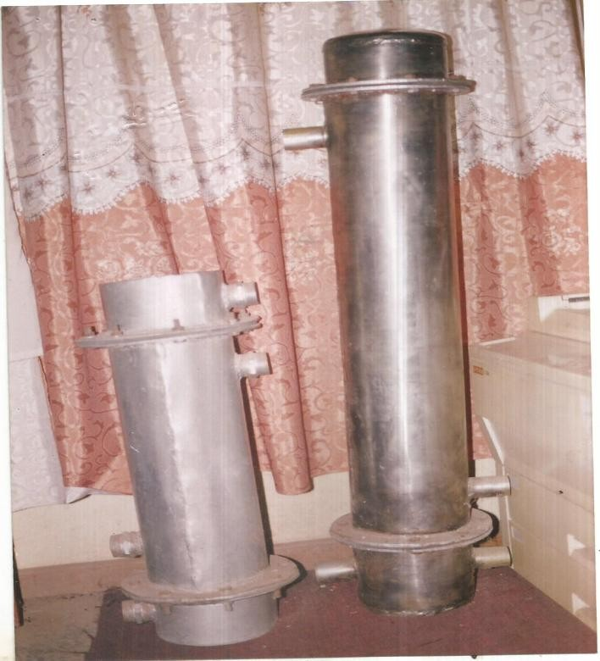

## FigureC-1: The photograph of the 1-2 and 1-2 shell and tube heat exchangers before transformation into prototype multiple heat transfer trainer

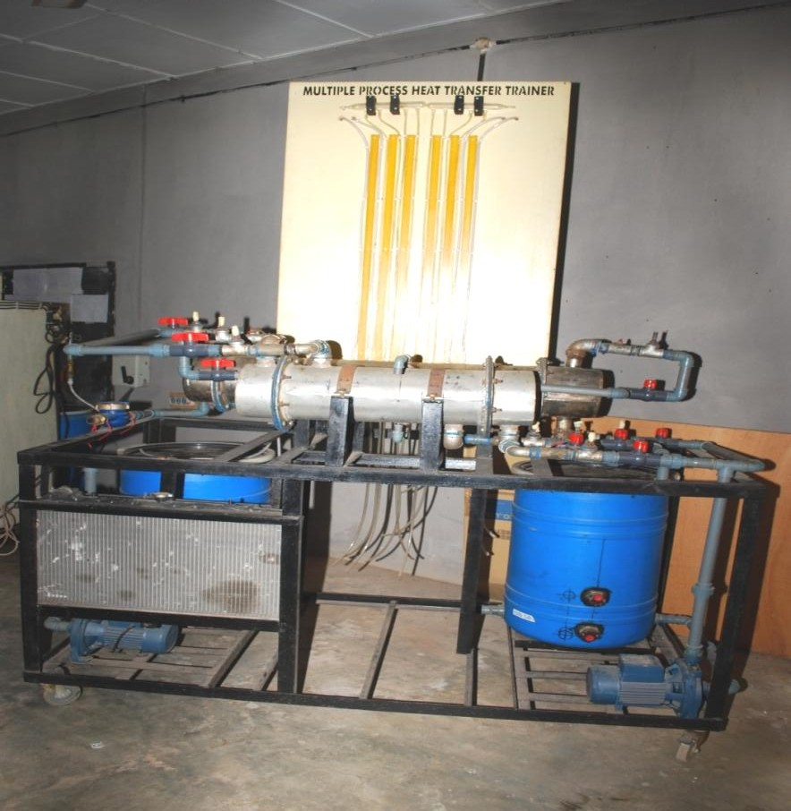

**Figure C-2: The photograph of front view of the prototype multiple process heat transfer trainer before installation of measuring instruments’ manifolds**

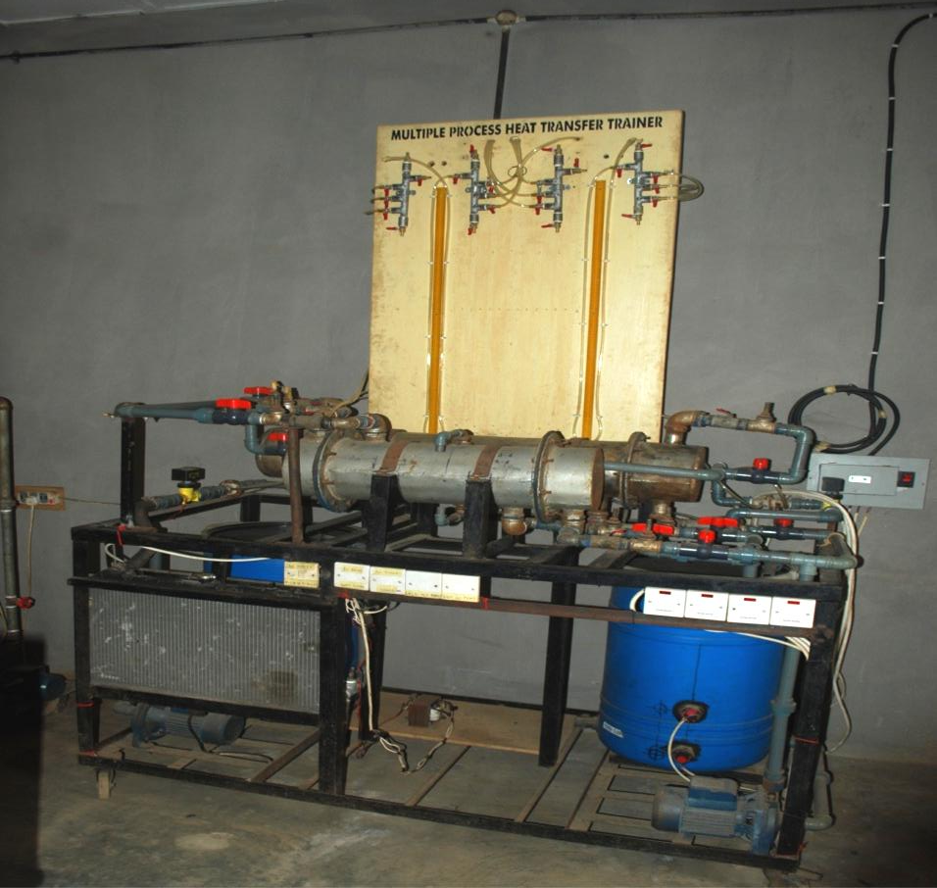

## FigureC-3: The photograph of front view of prototype multiple process heat transfer trainer before installation of measuring instruments’ manifolds

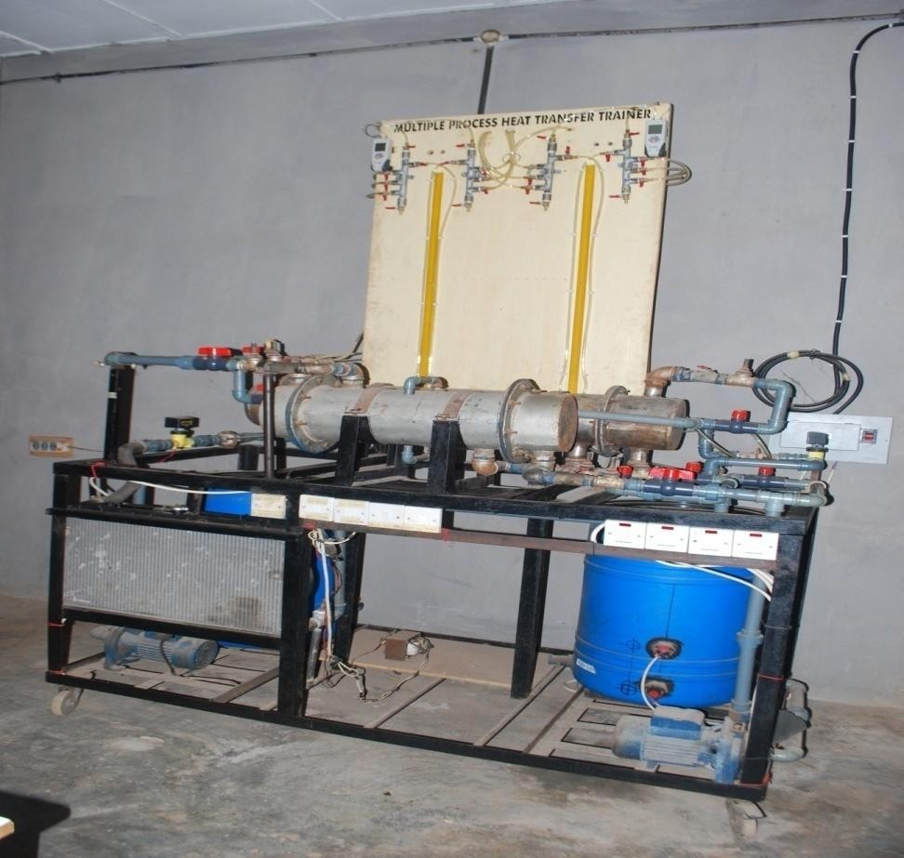

**FigureC-4:The photograph of front view of prototype multiple process heat transfer trainer after full installations of pumps and measuring instruments**

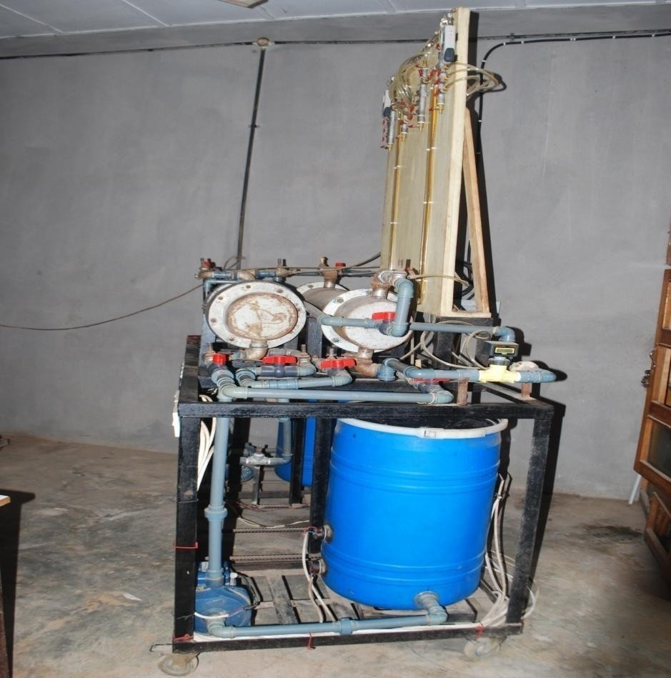

## Figure C-5: The photograph of side view of prototype multiple process heat transfer trainer after full installations of pumps and measuring instruments

**DEVELOPMENT OF PROTOTYPE MINIDUAL PACKED COLUMN TRAINER**

**By**

**OGUEJIOFOR George C. ILO Ugochukwu V.,**

**UMEMBAMALU, Chinedu J. Department of Industrial & Production Engineering Department of Chemical Engineering Nnamdi Azikiwe University**

**Nnamdi Azikiwe University Awka**

**Awka**

**Correspondences to:**

[**Email:oguejioforg@yahoo.com**](mailto:oguejioforg@yahoo.com)**, o**[**guejiofor.chiedozie@gmail.com**](mailto:guejiofor.chiedozie@gmail.com)

**Phone:+234(0)8035500882**

## ABSTRACT

An attempt was made at redressing the growing imbalance between engineering classroom poetry and engineering laboratory/field practices, which arose from the shortages of engineering teaching and research equipment in Nigeria. The attempt was the development of the bench scale prototype mini dual packed column trainer from the combined approach of chemical engineering principles and engineering craftsmanship. The engineering working drawing and sketches were developed. Guided by the drawing and the chemical engineering principles of a gas-liquid contactor, two glass columns were blown. They were provided with pressure tapping points, liquid entry and discharge points, and gas entrance and exist points. Broken palm kernel shells which approximated to 6mm ceramic Berl saddles were randomly packed in one of the glass columns already blown. While split periwinkle shells approximating to 6mm ceramic Rasching rings were randomly dumped into the other glass column. A steel frame was constructed and fitted with a vertical timber panel. The packed columns were mounted vertically on the timber panel. A constant head water circulator complete with centrifugal pump, in addition to other instruments and accessories namely air compressor, rotameters, digital electronic and differential manometers, manometer manifolds, flow-control valves and water/mercury seal were assembled on the steel frame and timber panel. By means of PVC pipe and flexible tube the accessories and instruments were connected to the packed columns through appropriate flow channels and ducts. With appropriate cables, the pump and air compressor were wired to the control switches and connected to the mains. Thus the prototype mini dual packed column trainer was completely and successfully developed(see prototype photograph). The prototype has the potential to make active for students and researchers Ergun’s correlation for pressure drop in single-phase flow and Leva’s correlation pressure drop in two-phase flow in packed beds. Also, it has the potentials of curbing ASUU’s agitations for equipmentation/improvement in education quality in Nigeria as well as diminishing the demand for foreign exchange for equivalent equipment importation.

Keywords: engineering-classroom poetry, engineering-laboratory

practice,gas-liquidcontactor,broken-palm-kernelshells,split-periwinkleshells,Ergun’s correlation, Leva’s correlation.

## EQUIPMENT DESCRIPTION

Given the fact that tower/column packings are the most expensive component of packed absorption towers, the mini dual packed column trainer is designed to adapt readily available indigenous materials as packings for absorption towers/columns. Some of such locally available materials are periwinkle shells and kernel shells which are applied as approximate substitutes for 3/8” Rashing ring packings and Berl saddle packings, respectively. This is consistent with the statement from Bill Gates that “you need to understand things in order to invent beyond them.”Thus, the mini dual packed column trainer is a compact and self-dependent apparatus. It has an angle iron frame and a vertical timber panel upon which are mounted: a constant head water circulator for ensuring steady water flow rate into the packed column and is made up of an overhead tank with central down comer, centrifugal pump and interconnecting pipes; a compressor with air tank which ensures steady airflow rate into the packed column; two glass columns packed with 3/8”periwinkle and kernel shell packings, respectively; water seals for the two packed columns which prevent the escape/leakage of gas from the bottom of the columns; two manometers namely the differential manometer and the digital manometer; two manometer manifolds which harnesses pressures from pressure tapping points and distributes them in the manometers; two digital/electronic rotameters for indicating water flow rates and gas flow rates into the packed columns; a network of tubings which connects the pressure tapping points to the manometer manifolds, and from the manifolds to the manometers, namely the electronic/digital and the differential manometers; two Y-splitters and their associated flow control valves for channeling water and air flows into any of the packed columns selected for experimentation; selected two on-off switches for the air compressor and centrifugal pump; as the photograph in the Appendix shows. The equipment is provided with swivel rollers for mobility.

## TEACHING AND RESEARCH CAPABILITIES

All the features described above, make the mini dual packed column trainer suitable for both students’ pedagogy and research. In this regard the equipment can accomplish the following research and teaching capabilities.

* Testing Ergun’s correlation for a single-phase flow across a periwinkle-shell packed column (or kernel-shell packed column) using the minidual packed column trainer.
* Verification of Leva’s equation for two-phase flow across a periwinkle shell-packed column (or kernel shell-packed column) using the minidual packed column trainer.
* Experimental determination of the packing factors for kernel-shell packings (and periwinkle shell packings) using the minidual packed column trainer.

However, the research topic envisaged is, “computer-enhanced two-phase flow through periwinkle and kernel shell packed columns using in house-developed mini dual packed column trainer”.

## DEPLOYMENT AND COMMERCIALISATION POTENTIAL

Packed absorption towers have wide spread usage in the process industry for the stripping/removal of gaseous pollutants such as oxides of carbon, sulphur and nitrogen from air streams. In the upstream petroleum industry, gas absorbers could be the remedy for the environmental acidification caused by routine gas flaring by oil/gas companies in Nigeria.

The oxides of nitrogen, carbon and sulphur produced by gas flaring and spewed into the atmosphere where they acidify and fall as acid rain, could be scrubbed or stripped or removed using packed absorption tower [Refer to Oguejiofor, 2000:99-114]. Thus gas absorption column or tower could be called a stripper or scrubber and gas absorption tower could be deployed for the duty of stripping/scrubbing pollutant gases in flue gas emitted at gas flare stations in Nigeria’s Niger Delta Petroleum fields.

## POSSIBLE INVESTORS

Tertiary institutions of learning and research institutes are potential investors given the fact mini dual packed column trainer is basically an engineering research and teaching equipment. Also, the major oil companies; Nigerian Petroleum Development Corporation, a subsidiary of NNPC; NOTORE (formerly NAFCON Ltd) and other R&D centres, could be potential investors owing to the fact that the mini dual packed column trainer substituted conventional packing materials with approximation of locally available materials. SEDI and NOTAP could catalyse and enhance investors’ take-up.

## REFERENCE

Oguejiofor George C. (2000). Gas Flaring In Nigeria: Converting Flue Gas Pollutants Into Revenue-earning Fertilizer by the Low-cost Retrofitting of Flare Stations, The International Journal of Environmental & Life Sciences, University of Salford, UK, Vol. 19 No. 2 pp. 99-114,April – June 2000.

# F:\burn\DSC_0031.JPGAPPENDIX

## Figure D-1: The front view photograph of the prototype mini dual packed column trainer before fitting the electronic manometer

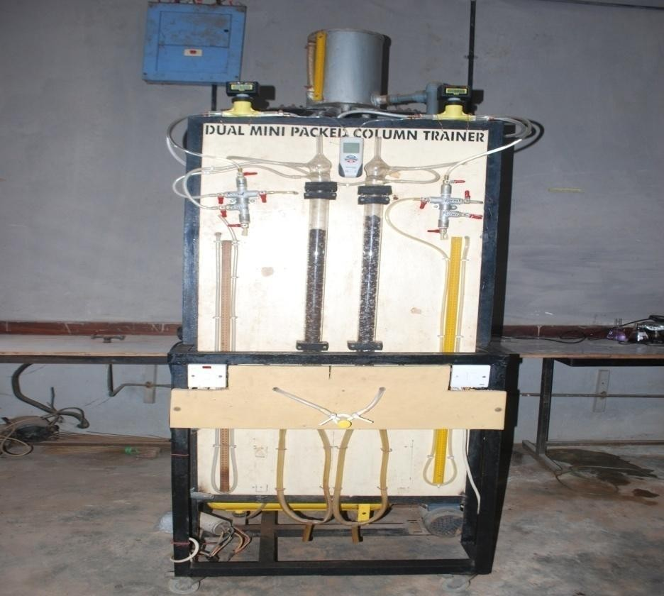

**FigureD-2: The front view photograph of the prototype minidual packed column trainer after fitting the electronic manometer**

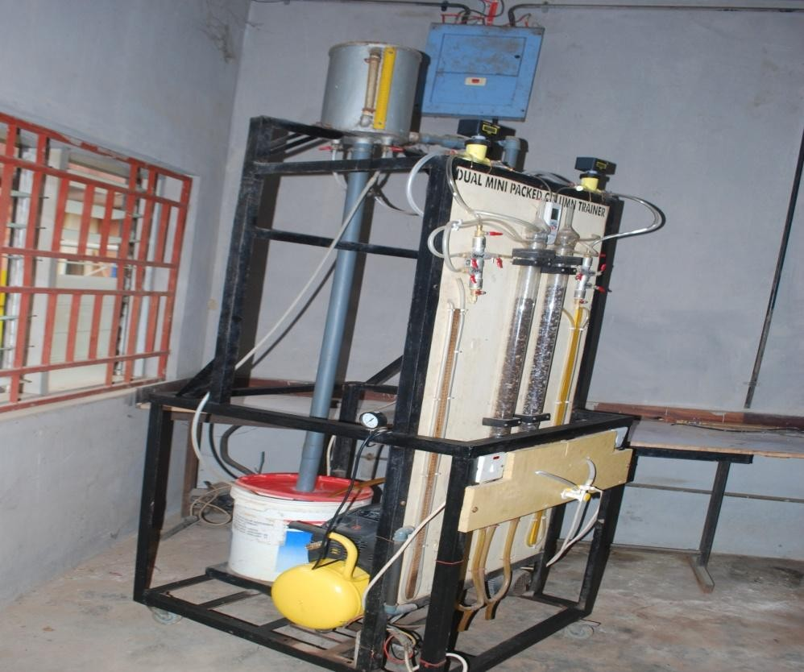

## FigureD-3: The diagonal view photograph of the prototype minidual packed column trainer after fitting the electronic manometer

**DEVELOPMENT OF PROTOTYPE CONSTANT HEAD WATER CIRCULATOR**

**By**

**OGUEJIOFOR George C. NWOKEOCHA Tochukwu,**

**Department of Chemical Engineering Department of Industrial & Production**

**Engineering Nnamdi Azikiwe University Nnamdi Azikiwe University**

**Awka. Awka.**

**Correspondences to:**

[**E-mail:oguejioforg@yahoo.com**](mailto:oguejioforg@yahoo.com), **o**[**guejiofor.chiedozie@gmail.com**](mailto:guejiofor.chiedozie@gmail.com)

**Phone:+234(0)8035500882**

## ABSTRACT

The need to equip engineering and science laboratories for accreditation requirements and also to replace/substitute gravity siphon system for the convenience of students and researchers motivated the development of the prototype constant head water circulator. By mental articulation, the constant head water circulator was a programmed technical cocktail of joining together, an overhead constant head tank, base water reservoir/tank, and water circulating pump by means of pipelining on a bench scale steel framework. The articulation was physically actualized by means of engineering craftsmanship/technical know-how and the result was the prototype constant head water circulator shown in the enclosed photograph. The prototype has the proven pedagogic value of providing effort-free water circulation through the condensers of soxhlet extractors, distillation columns and the likes, for the convenience of the students and researchers working in engineering and science laboratories. The prototype has the potential of curbing ASUU agitations for laboratory equipmentation and quality education in Nigeria as well as Saving Nigeria the foreign exchange needed for importing equivalent equipment.

Keywords: gravity-siphon system, constant-head tank, mental articulation, programmed-technical cocktail, engineering craftsmanship, pedagogic value, ASUU agitations.

**EQUIPMENT DESCRIPTION**

Most laboratories in Nigeria run cooling water through the condensers of bench-scale distillation and extraction apparatuses by the process of gravity siphon. The gravity siphon consists of two buckets, with one positioned at an elevation higher than the condenser elevation while the other bucket is placed at an elevation lower than the condenser elevation. The separate ends of the tubes connected to the condenser are immersed into the buckets at higher and lower elevations. By gravity water flows from the bucket at the top elevation through the condenser at the middle elevation to the bucket at the bottom elevation.

Unfortunately, this type improvisation distracts the researcher/experimenter from focusing on theexperimentaltarget,whichcouldbedistillationorextraction.Thisisbecausetheresearcher/experimenter has to keep an eye on the bucket at the bottom elevation to determine when to transfer by manual means the water collected in that bucket to the bucket at higher elevation. This laborious problem was eliminated by the development of the constant head water circulator.

The constant head water circulator consists basically of: a steel framework made from angle iron and is fitted with swivel rollers for mobility; plastic base tank; centrifugal pump; overhead constant head tank; pvc pipe connecting base tank through centrifugal pump to the constant head tank at the top of the equipment (see photograph in the Appendix).The centre of the constant head tank is fitted a down comer pipe which prevents water from overflowing the tank and spilling over the equipment. The central down comer ensures that water returns by gravity to the base tank, from where it is lifted by the centrifugal pump to the overhead constant head tank; thus ensuring steady circulation. At the bottom of the overhead constant head tank are tapping points with 8mm ball valves, which allow cooling water to be taken to the laboratory process equipment such as distillation condensers and extraction condensers. The ball valves at the tapping points allow adjustment and control of cooling water delivery into the condensers of the laboratory process equipment. The warm water from the condensers are returned by tube into the base tank thus ensuring that spillage and splashing of water is prevented.

**TEACHING AND RESEARCH CAPABILITIES**

The constant head water circulator is a utility equipment or service equipment. Therefore its teaching and research capabilities are to support the laboratory process equipment such as distillation or extraction condensers with steady and uninterrupted cooling water supply. It is also a labour-saving device for the researcher/experimenter because the equipment eliminated the problem of manually transferring water from the bucket at the base elevation to the bucket at the top elevation, as is the case with the gravity siphon improvisation.

**DEPLOYMENT AND COMMERCIALISATION POTENTIAL**

Constant head water circulator is useful in engineering and science laboratories for maintaining steady and constant flow rate of liquid into process equipment. To beat flow rate fluctuations caused by centrifugal pump pulsations, and electric current in stability, constant head water circulators are usually deployed for service. This makes the constant head water circulator commercial is able for laboratory applications.

**POSSIBLE INVESTORS**

Since technology does not discriminate, it belongs to anyone who needs it and who could invent, innovate, acquire or buy it out rightly. Thus universities, polytechnics, tertiary technical colleges, engineering/science research institutes and collectors of engineering innovations are the possible investors. SEDI and NOTAP could serve as the agents of the possible investors.

# APPENDIX

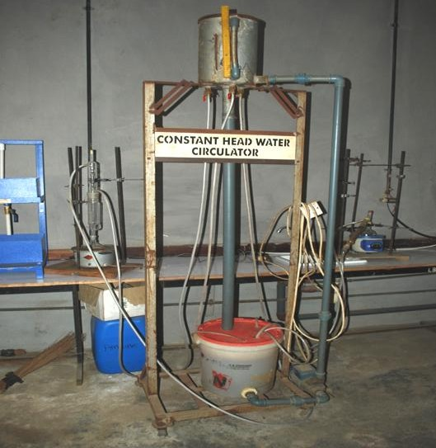

**FigureE-1:The photo graph of the prototype constant head water circulator**

## DEVELOPMENT OF PROTOTYPE FLOW MEASUREMENT AND HEAT TRANSFER TRAINER

**By**

**OGUEJIOFOR George C. ILO Ugochukwu V.**

**UMEMBAMALU Chinedu J. Department of Industrial & Production Engineering Department of Chemical Engineering Nnamdi Azikiwe University**

**Nnamdi Azikiwe University Awka**

**Awka**

**Correspondences to:**

[**E-mail:oguejioforg@yahoo.com**](mailto:oguejioforg@yahoo.com), **o**[**guejiofor.chiedozie@gmail.com**](mailto:guejiofor.chiedozie@gmail.com)

**Phone:+234(0)8035500882**

## ABSTRACT

A technical articulation captioned flow measurement and heat transfer trainer was conceptualised for exposing engineering students to bench scale training equipment. By paper design, the conceptualised trainer was predicated upon heat loss through heat transfer test pipe and liquid flow through flow measurement test pipe. Articulated onto the flow measurement test pipe were vertically positioned orifice, gate value, ball value and rotameter, as well as horizontally positioned orifice and flow diffuser. Pressure tapping points at the entrance and exit were articulated on to all these flow devices. Another aspect of the articulation was a tank fitted with electric thermostat heaters, a centrifugal pump as well as differential and electronic manometers linked together by a manifold. By construction, the paper design guided a structured technical concoction which involved fitting, pipelining, tubing and wiring for the physical actualisation of the prototype flow measurement and heat transfer trainer. The enclosed photograph showed the completely developed prototype flow measurement and heat transfer trainer. The prototype has the proven potential to assist in determining axial heat loss from single bare pipe to the surrounding environment as well as evaluating energy losses and pressure drops across orifices, valves and flow diffuser. Also, it has the potential of assisting engineering disciplines in meeting the NUC and COREN accreditation requirements as well as curbing ASUU agitations for quality education and engineering laboratory equipmentation.

Keywords: technical articulation, bench-scale-training equipment, flow-measurement test pipe, heat-transfer test pipe, paper design, structured-technical concoction.

## EQUIPMENT DESCRIPTION

The flow measurement and heat transfer trainer is conceived and produced as a portable and self contained unit (see photograph). It is made up of a support frame which is fitted with swivel rollers for mobility. On the support-frame structure are mounted sump tank, centrifugal pump, heat transfer test pipe, flow measurement test pipe and instrumentation panel. The sump tank houses three heater elements, each of which is incorporated with adjustable set point thermostat. The centrifugal pumps is electric-current driven and is the prime mover of the equipment. The heat transfer test pipe is made of galvanized steel and is fitted with thermo wells at the pipe exit and entry to ensure adequate coverage of axial and radial heat transfer by conduction, convection and radiation. The flow measurement test pipe is also made of galvanized pipe and is fitted with aball valve, a gate valve, a flow diffuser, a horizontally-mounted orifice, a vertically-mounted orifice, arotameter and flow control valve. All these fittings are provided with pressure tapping points to ensure pressure drop measurement during fluid flow. The instrumentation panel contains two manometer manifolds, a differential manometer and an electronic manometer for complementing and comparing measurements made from the differential manometer. All the fittings are connected by tube to the manometer manifolds (see photograph in the Appendix).

## TEACHING AND RESEARCH CAPABILITIES

All the components and fittings mentioned above provide the equipment with assorted teaching and research capabilities and they are:

* Comparative analysis of liquid flow through horizontally and vertically-mounted orifices.
* Pressured rope valuations of liquid flow through ball and gate valves.
* Liquid flow through a horizontal diffuser.
* Using surface response methodology for optimizing heat loss to the surroundings from forced circulation of hot water in bare pipe.
* Verification of Bernoulli equation under turbulent flow.

However, the research topic predicated is,“ software-assisted analysis of liquid flow through horizontal and vertical orifices using in house-developed equipment”.

## DEVELOPMENT AND COMMERCIALIZATION POTENTIAL

Flow measurement and heat transfer trainer is an equipment which is useful in the education and training of engineers of assorted cadres. The insights and understanding gained from the practical training with the equipment would ensure their industrial applications in real life situations. Thus, the flow measurement and heat transfer trainer is made available for commercialization and deployment in engineering students’ upbringing.

## POSSIBLE INVESTORS

Universities, polytechnics, technical colleges of education, engineering research institutes and engineering equipment enthusiasts are the possible investors. SEDI and NOTAP are valuable resources in the commercialisation drive.

# APPENDIX

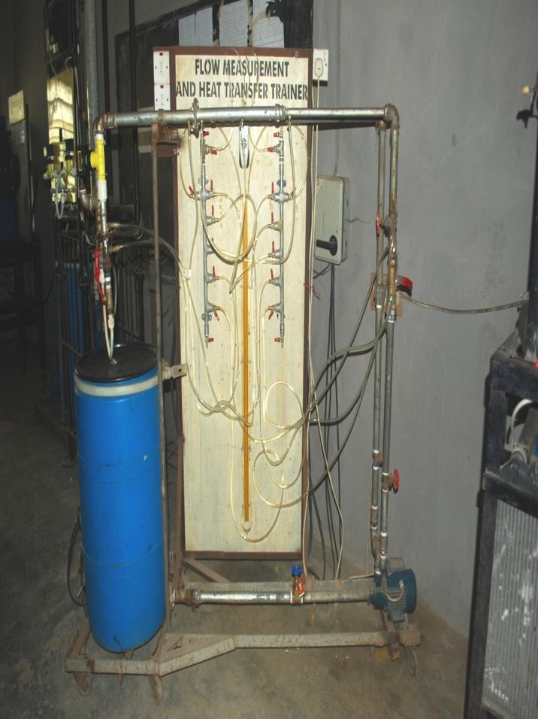

**Figure F-5: The photograph of the prototype flow measurement and heat transfer trainer**

# PILOT PLANT PACKED ABSORPTION TOWER

**By**

**OGUEJIOFOR George C. OTUU Obinna**

**IGBINEWEKA Esosa, UKOHA Felix I.**

**Department of Chemical Engineering Science Equipment Development Institute**

**Nnamdi Azikiwe University Akwuke**

**Awka Enugu.**

**Correspondences to:**

[**E-mail:oguejioforg@yahoo.com**](mailto:oguejioforg@yahoo.com), **o**[**guejiofor.chiedozie@gmail.com**](mailto:guejiofor.chiedozie@gmail.com)

**Phone:+234(0)8035500882**

**EQUIPMENT DESCRIPTION**

The assembly of various components, instruments, auxiliaries and fittings formed the pilot plant packed absorption tower. The absorption column consists of a glass column harbouring ¼ inch Rasching rings, packing support plate, liquid distributor and liquid seal; and all of these are fitted on to a scaffold structure which houses and supports them as the photograph shows. The scaffold is built with 2 inches diameter pipe. The auxiliaries are the holding tank and current-driven centrifugal pump for delivering water through the pipeline to the liquid distributor at the top of the glass column. Another auxiliary is the rotary compressor which pumps compressed air to the bottom of the packed tower. The water seal is a glass U-tube. The maximum supply gas pressure which can be used in this tower is limited by the height of the water seal, which in this case is 24 inches water gauge (WG).The instruments are fitted on the instrumentation panel and they are namely, the rotameter for air flow rate, the rotameter for water flow rate and two-input electronic manometer for measuring pressure differential across the packed column (see the photograph).The fittings are the plumbing fittings and the flow control niddle valves for both the water circuit and air flow duct. While the electrical fittings are the controls witches for the rotary compressor and centrifugal pump and the associated cables. The pilot plant packed absorption tower is not movable as the photograph shows (see Appendix).

**TEACHING AND RESEARCH CAPABILITIES**

All the features described above about the pilot plant packed tower makes it suitable for practical teaching of gas absorption. Thus the experimental capabilities include:

* + Pressure drop across rasching-ring packed to were for both air and water systems
  + Verification of Leva’s correlation
  + Verification of Ergun’s correlation
  + Verification of Carman-Kozeny equation
  + Determination of loading and flooding points in a packed tower
  + Demonstration of the principles of gas absorption into a liquid using a packed power. However, there search topic predicated is, “computer-aided gas absorption using home-grown pilot plant packed absorption tower”.

**DEPLOYMENT AND COMMERCIALIZATION POTENTIAL**

Packed absorption towers are used in the purification of acid gases which contaminate natural gas. Acid gases are oxides of carbon, oxides of nitrogen and oxides of sulphur. In the gas natural industry the process applied in removing these acid gases from natural gas is known as sweetening process. Aqueous solutions of mono-ethanolamine (MEA) or di-ethanolamine (DEA) are the most widely used in the upstream natural gas production industry for the sweetening of raw natural gas in gas absorption towers. In the downstream natural gas processing industry, the NLNG uses DEA for acid gas removal in gas absorption towers. However, in some gas industry, a combination of glycol process and ethanolamine process known as the glycol amine process is used. This is mostly applied for simultaneous dehydrating of natural gas and removal of acid gas impurities in giant gas absorption towers. The absorbents are regenerated by stripping out the acid gas by heating and then recycled or re-circulated into the gas absorber. In the former NAFCON and other fertilizer plants built by M.W. Kellogg Benfield solution is used for absorbing/removal of acid gases from raw natural gas in its gas purification process which takes place in giant gas absorption towers. Before the advent of MEA and DEA sweetening processes, water at2 atmospheres and150C was used in the absorption tower for absorbing some acid gases namely the oxides of carbon and sulphur from gas streams. Thus gas absorption towers are valuable in the upstream gas production sector, downstream gas processing sector, the chemical process industry, as well as in the education and training of engineers in tertiary institutions of learning.

**POSSIBLE INVESTORS**

Universities, polytechnics, technical colleges and research institutes are the possible investors who need gas absorption towers for preparing their engineering students for meeting up with the requirements of operating and managing the giant gas absorption towers employed by, upstream gas production companies, downstream gas processing corporations (NLNG,NAFCON now Notore) for the absorption of acid gases from natural gas streams. However, SEDI and NOT A Pare valuable partners for any kind of investors, whether educational investors or industrial investors.

## APPENDIX

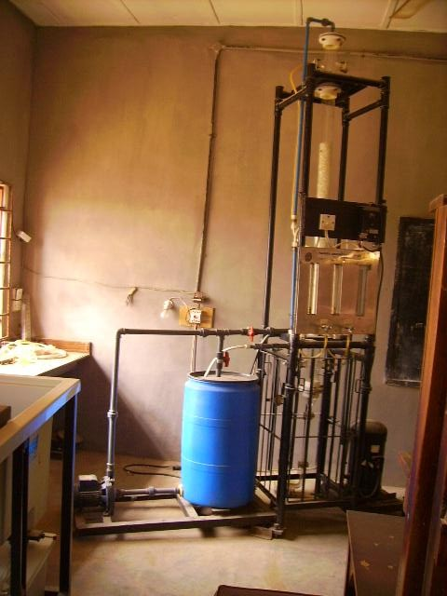

**FigureG-1a: The photograph of the prototype pilot plant packed absorption tower before renovation and upgrade.**

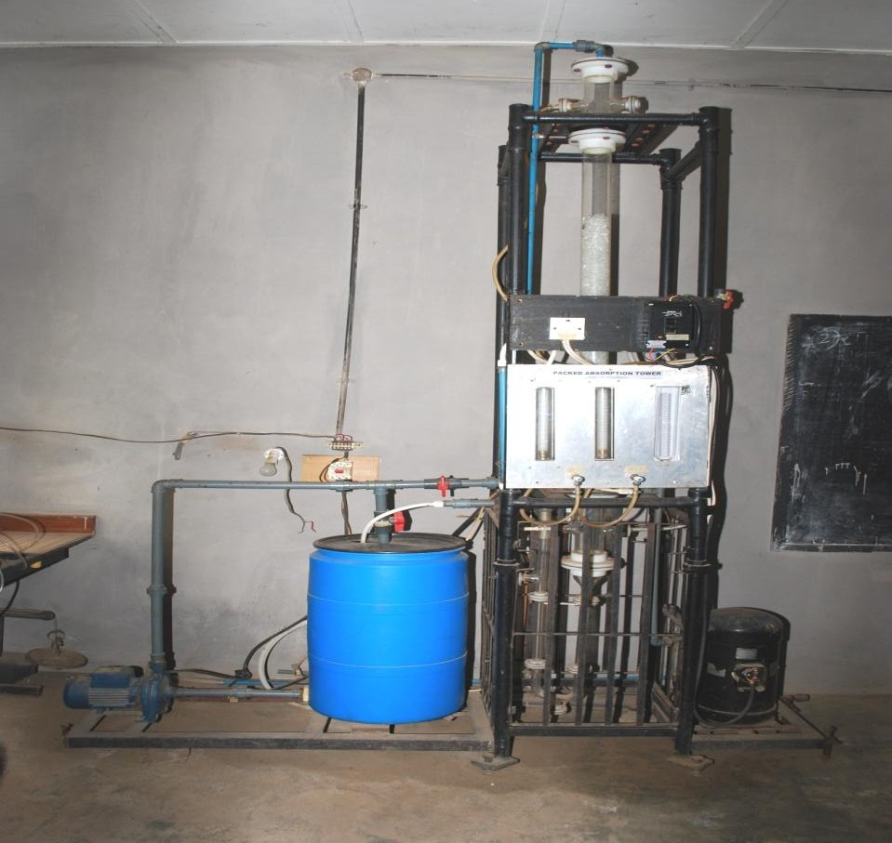

## FigureG-1b: The photograph of the prototype pilot plant packed absorption tower before renovation and upgrade.

**RETOOLING OF PROTOTYPE PILOT PLANT PACKED ABSORPTION TOWER**

## by

**Oguejiofor George C., Nwobodo Valentine, Emembolu Lovet N. Umembamalu Chinedu J. and Ohale Paschal.**

Department of Chemical Engineering, Nnamdi Azikiwe University, Awka

## Correspondences to:

E-mail:[oguejioforg@yahoo.com](mailto:oguejioforg@yahoo.com), [oguejiofor.chiedozie@gmail.com](mailto:oguejiofor.chiedozie@gmail.com)

**Phone**:+234(0)8035500882

## ABSTRACT

Motivated by the need to improve the responsiveness and sensitivity of the measuring instruments for the prototype pilot plant packed absorption tower, a retooling project was undertaken on the instrumentation panel. The prototype pilot plant packed absorption tower was a home-grown teaching and research equipment constructed by Science Equipment Development Institute (SEDI) and Nnamdi Azikiwe University’s Chemical Engineering Department. The prototype retooling was executed by replacing the home-developed instruments namely, the glass-tube rotameters in the air and water pipelines as well as the mercury differential manometer with their imported equivalents, namely digital electronic rotameters and manometer. The enclose photograph showed there tooled instruments panel of the prototype pilot plant packed absorption tower. It was expected that the prototype retooling would enhance the demystification of Leva’s and Ergun’s pressure drop correlations and help in redressing the apathy for engineering practicals in Nigerian universities.

Keywords: Prototype retooling, responsiveness/sensitivity, digital-electronic instruments, home-developed instruments, demystification, pressure-drop correlations.

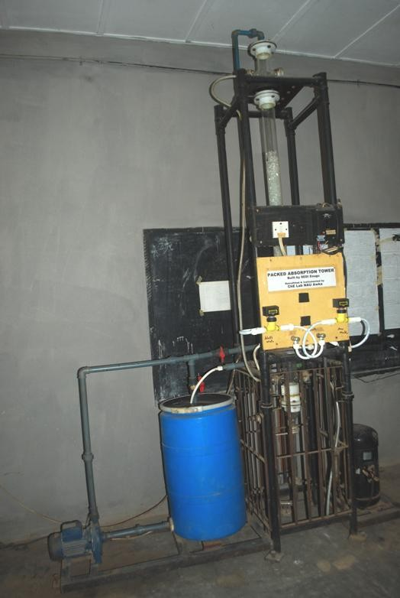**APPENDIX**

**FigureH-1:The photograph of the prototype pilot plant packed absorption tower after retooling with electronic rotameters and manometer.**

# VISUAL LIQUID FLOW LAB TRAINER

**By**

**ABSTRACT**

**(Abstract available in JORMAR)**

This abstract was excerpted from the Journal of Raw Materials Research, JORMAR6 (1) 2011, p.78

**OGUEJIOFOR George C. OMENYI Sam**

**Department of Chemical Engineering Department of Mechanical Engineering Nnamdi Azikiwe University Nnamdi Azikiwe University**

**Awka Awka**

**Tochukwu Nwokeocha**

**Department of Industrial & Production Engineering**

**Nnamdi Azikiwe University Awka**

**Correspondences to:**

[**E-mail:oguejioforg@yahoo.com**](mailto:oguejioforg@yahoo.com), **o**[**guejiofor.chiedozie@gmail.com**](mailto:guejiofor.chiedozie@gmail.com)

**Phone:+234(0)8035500882**

**EQUIPMENT DESCRIPTION**

The visual-liquid flow trainer is a bench-scale equipment retrofitted to ensure that students who use it are accustomed to devices for pressure drop, flow measurements and calibrations. The equipment consists of a bench framework, glass test pipe which ensures transparency and visual observation of fluid flow, and instrumentation panel (see photograph).The test pipe is mounted at the corner of the horizontal plywood table top and the vertical board (the instrumentation panel).The test pipe is made of borosilicate glass and contains the horizontally fitted flow diffuser (enlarger), the venturimeter, the orifice meter, the horizontal-to-vertical 900 smooth bend and the vertically-mounted rotameter.

The instrumentation panel is fitted with a bank off our inverted u-tube differential manometers and one vent tube. The range of those manometers is 0-440mm of water differential. By means of 6mm tubing, each of the limbs of the bank of four u-tube manometers is connected respectively to the tapping points fitted on the diffusers, venturimeter, orifice meter and 900 bend. The result is that the pressure differential (h1-h2) between the two tappings on the diffuser, venturimeter, orifice meter and 900 bend can be evaluated by the expression ΔP=eg (h1-h2).

**DEMONSTRATION AND TEACHING CAP ABILITIES**

Based on the fittings and instruments provided on the testpipe of the visual liquid flow trainer the following demonstration and teaching capabilities are available on the equipment:

* Verification of head loss around a bend from the perspectives of velocity head (k) and equivalent length (Le) of the pipeline.
* Determination of the coefficient of contraction (Cc) for a vertically-mounted rotameter.
* Head loss across flow diffuser
* DeterminationofthecoefficientofdischargeCDforventurimeterandorificemeter.

## DEPLOYMENT AND COMMERCIALIZATION POTENTIAL

Flow measurements and its visualization due to the transparency of the glass with which the testpipe is constructed would enable students to readily accustom with the behavior of fluids at bends, venturimeters, orificemeters and rotameters. Therefore this equipment is deployable for engineering students at all categories of tertiary education in Nigeria.

## POSSIBLE INVESTORS

Universities, polytechnics, technical colleges, research institutes and training schools of oil/gas companies, as well as chemical process industries are possible investors. SEDI and NOTAP could act as vehicles for attracting investors as well as its commercialization.

# APPENDIX

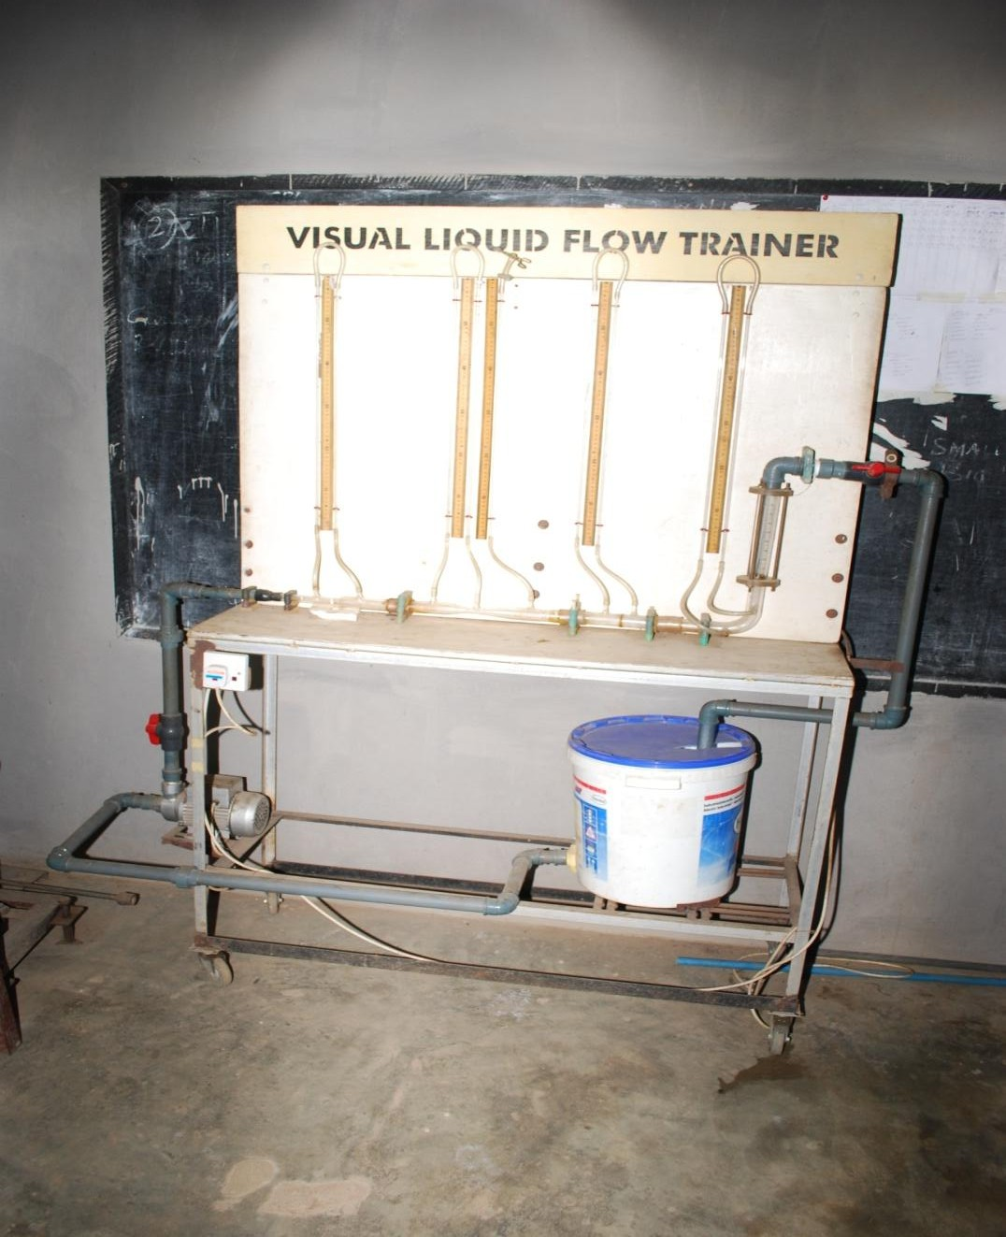

**Figure I-1: The photograph of the prototype visual liquid flow lab trainer after completion and commissioning**

## INNOVATION OF PROTOTYPE LIQUID-LIQUID REACTOR TRAINER

**By**

**OGUEJIOFOR George C. ILO Ugochukwu V.,**

**NWOBODO Valentine Department of Industrial & Production Engineering**

**UMEMBAMALU, Chinedu J. Nnamdi Azikiwe University**

**EMEMBOLU Loveth N. Awka**

**Department of Chemical Engineering Otuu Obinna**

**Nnamdi Azikiwe University Science Equipment Development Institute**

**Awka Akwuke, Enugu**

**Correspondences to:**

[**E-mail:oguejioforg@yahoo.com**](mailto:oguejioforg@yahoo.com), **o**[**guejiofor.chiedozie@gmail.com**](mailto:guejiofor.chiedozie@gmail.com)

**Phone:+234(0)8035500882**

## ABSTRACT

The struggles for deepening the practical contents in engineering education and also providing the equipment for meeting the NUC and COREN accreditation requirements were the driving forces for the innovative development in engineering teaching and research equipment. A stirred tank glucose reactor lying redundant in mechanical engineering laboratory, Nnamdi Azikiwe University, Awka, was picked up and transformed into a prototype bench scale liquid-liquid reactor trainer by structured retrofitting for self dependency. The transformation and retrofitting were approached from engineering craftsmanship and chemical engineering principles. A steel frame was fabricated and fitted with a vertical wooden panel. The reactor already jacketed for cooling/heating water circulation was mounted on the steel frame, while two reactant reservoirs were fitted overhead on the wooden panel to ensure the supply/delivery of the reactants to the reactor by gravity. A hot water tank fitted with three thermostat water heaters, a centrifugal pump and a constant-head tank were assembled on the steel frame and connected together to form a hot/cold water constant head circulating system for delivering heating/cooling water into the reactor jacket. Also, the reactor was provided with a vacuum pump, vacuum flask and vacuum hose system for reaction product evacuation. Electrical wiring was undertaken with appropriate cables which connected the electric heaters, vacuum pump, centrifugal pump and reactor motor stirrer to the mains power supply through their respective control switches. The innovative process was complete and the prototype liquid-liquid reactor trainer was configured into a research/teaching equipment architecture at bench scale level. (See the photograph of liquid-liquid reactor trainer). The prototype has the potentials for assisting students and researchers in practically determining the chemical kinetic parameters namely reaction rate law, reaction rate coefficient and Arrhenius temperature dependency model. Besides, the prototype has the potential of foreign exchange savings on equivalent equipment importation and reducing the disruptive strike actions by Academic Staff Union of Universities (ASUU) for laboratories’ equipmentation in Nigerian Universities.

Keywords: Practical contents, stirred-tank-glucose reactor, structured retrofitting, teaching-equipment architecture, chemical-kinetic parameters, laboratories’ equipmentation.

## EQUIPMENT DESCRIPTION

Liquid-liquid reactor trainer was previously a glucose reactor until it was converted into a teaching and research equipment by imposing teaching equipment architecture into its structure, and also retrofitting it with relevant accessories and technical devices. This retrofitted feature ensures the functionality of the reactor’s cooling water jacket provided and the means of evacuating the product of the reaction. The liquid-liquid reactor trainer is a system and this system building blocks comprises: steel bench and a vertical timber board; 4litres reactor with baffles and stirrer, temperature control unit and cooling/heating water jacket; constant head water circulating device incorporating constant head tank, centrifugal pump and tank with three heater elements; product removal system made up of vacuum pump, 2litres vacuum flask and vacuum hose; two

2.5 litres overhead reactants’ tank with calibrations; six on-off switches namely for three heater elements, centrifugal pump, vacuum pump and temperature control unit. The enclose photograph in the Appendix shows the configuration and structure of the liquid-liquid reactor trainer. The equipment is provided with swivel rollers for mobility.

**TEACHING AND RESEARCH CAPABILITIES**

The components and features of the liquid-liquid reactor trainer equipped it with the capabilities of containing the under listed experiments.

* Investigation of Frendrich and Langmurisotherm for any binary reacting systems.
* Determinationofreactionratecoefficientandorderofreactionforanybinaryreactingsystems.
* Variation of conversion with residence time(ҭ)for saponification reaction between ethylacetate and sodium hudroxide.
* Variation of reactionrateconstant(k)withtemperature(T)usingArrheniusequationfor the reaction of ethylacetate with sodium hydroxide.
* Semi pilot plant scale biodiesel production studies.

However, there search topic envisaged is, “computer-aided kinetics of ethylacetate-sodium hydroxide hydrolysis using home-grown liquid-liquid reactor trainer”.

**DEPLOYMENT AND COMMERCIALIZATION POTENTIAL**

The usage of reactors cuts across several disciplines. In chemical engineering and chemistry disciplines reactors are called chemical reactors. In biochemistry discipline reactors are known as bio-reactors. In microbiology discipline reactors could be called culture vessels. Example in the brewery the yeast for fermenting wort into beer is usually initiated in the laboratory in a culture vessel called clask flask by the microbiologist and subsequently grown in the east propagation plant in the fermentation section.

Thus the commercialization potential of reactors is highly promising in view of the above submission.

## POSSIBLE INVESTORS

Breweries; research institutes; universities; polytechnics; tertiary technical colleges; Nigerian Petroleum Development Corporation, a subsidiary of NNPC; training schools in petroleum refineries, petrochemical plants, sugar refineries, and other chemical process plants/facilities. This is a trainer reactor, which is a fore runner to training/operation of industrial-scale reactor. Thus any industry that uses a reactor should need the liquid-liquid reactor trainer for training its personnel. SEDI and NOTAP could be helpful as vehicles for attracting investors for commercialization purposes.

# APPENDIX

**Figure J-1: The photograph of the prototype liquid-liquid reactor trainer after completion and commissioning**

## INNOVATION OF PROTOTYPE ASSORTED SOLIDS CRUSHER TRAINER

**By**

**OGUEJIOFOR George C. ILO Ugochukwu V.,**

**ONUKWULI Okechukwu D. Department of Industrial & Production Engineering ATUANYA Uche C. Nnamdi Azikiwe University**

**UMEMBAMALU, Chinedu J. Awka**

**OLAITAN Samuel A.**

**Department of Chemical Engineering Nnamdi Azikiwe University**

**Awka**

**Correspondences to:**

[**E-mail:oguejioforg@yahoo.com**](mailto:oguejioforg@yahoo.com), **o**[**guejiofor.chiedozie@gmail.com**](mailto:guejiofor.chiedozie@gmail.com)

**Phone:+234(0)8035500882**

## ABSTRACT

In order to show that mental colonisation was partly responsible for Nigeria’s dependence on imported engineering teaching equipment, a home-grown initiative for transforming a rotary plastic crusher into a prototype assorted solids crusher trainer was undertaken. A plastic crusher in redundancy in chemical engineering laboratory, Nnamdi Azikiwe University, Awka, was picked up and converted into a bench scale prototype trainer for assorted solids. The combination of technical know-why gained from chemical engineering principles and technical know-how gained from engineering craftsmanship drove the technical innovation process. To this end, three alternating current (ac) ammeters, three acvoltmeters, a three phase variable speed electric motor and an electric motor control were incorporated into the prototype architecture for ensuring that engineering pedagogic values are inculcated on students and users of the prototype crusher. The prototype was wired with appropriate cables and control switches for three phase power supply from the mains to the electric motor. By all these processes, the prototype was shaped into teaching equipment architecture. The enclosed photograph (see Appendix) showed the fully innovated prototype assorted solids crusher trainer. The prototype has the potentials for aiding students and researchers in experimental investigation of communution (crushing) kinetics and crushing-power requirements in relation to kick’s law, Rittinger’s law and Bond’s law of crushing. Also, the prototype has the potentials of reducing foreign exchange demand for equivalent equipment importation and improving the quest of Nigerian universities for global status.

Keywords: Home-grown initiative, technical-innovative process, Technical know-why, technical know-how, engineering-pedagogic values, crushing-power equipments.

## EQUIPMENT DESCRIPTION

Assorted solids crusher trainer was originally a plastic crusher until it was transformed into a teaching equipment by providing it with teaching equipment architecture and retrofitting with instruments and accessories to ensure its suitability for engineering pedagogy. The equipment building blocks comprise: steel bench and timber instrumentation panel; three phase variable speed motor rated at 1.5 horse power for driving the crusher; three phase motor regulator; three phase control switch; the solids crusher; three ammeters rated at0-10Amps; voltmeter rated at 0-450 volts; as the enclosed photograph shows. The equipment is provided with swivel rollers for mobility.

**DEMONSTRATION AND TEACHING CAPABILITIES**

All the accessories listed above and their abilities to withstand variations and constancies make the assorted solids crusher trainer suitable for the training of engineering students. To this end, the equipment can accomplish the under listed teaching and demonstration capabilities.

* Using Kick’ slaw of crushing as the basis for evaluating power requirement for assorted solids crusher trainer
* Applying Rittinger’s law of crushing as the basis for evaluating power requirement for Assorted Solids Crusher Trainer.
* Evaluating power requirement for Assorted Solids Crusher Trainer from the perspective of Bond’s law of crushing.

## DEPLOYMENT AND COMMERCIALIZATION POTENTIAL

Solid crushers are useful in the mining industry for the communution of solid minerals and ores which could serve as feedstock or raw materials for the chemical process industry. Inside the chemical process industry solid crushers could be employed in the pulp and paper factory as well as the ceramics factory for size reduction of papers and ceramics respectively. In the pulp and paper factory, waste papers are usually shredded to pieces by solid crushers before their transfer into pulping vessels. Therefore the assorted solids crusher trainer is valuable process equipment in the pulp and paper factory.

## POSSIBLE INVESTORS

Tertiary institutions of learning, research institutes, ceramic industry, pulp and paper industry are the few possible investors of the crushers. Also, poultry farmers and animal breeders need crushers for preparing animal feeds from agricultural produce and residues. SEDI and NOTAP could be the vehicles for investors’ attraction and commercialization.

## APPENDIX

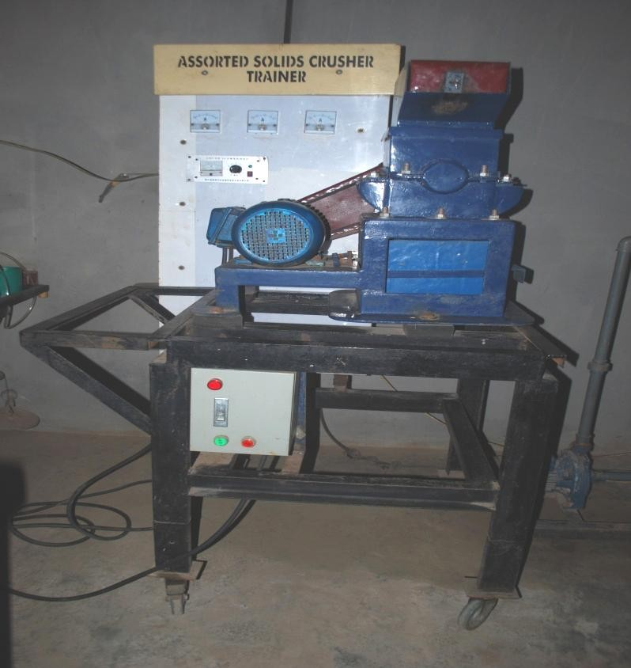

**Figure K-1: The photograph of assorted solids crusher trainer after completion and commissioning**

## INNOVATION OF PROTOTYPE VENTURI AIR TUNNEL TRAINER

**By**

**OGUEJIOFOR George C. ILO Ugochukwu V.**

**OHALE Paschal E. Department of Industrial & Production Engineering**

**UMEMBAMALU, Chinedu J. Nnamdi Azikiwe University**

**EMEMBOLU, Lovet N. Awka**

**Department of Chemical Engineering**

**Nnamdi Azikiwe University**

**Awka**

**Correspondences to:**

[**Email:oguejioforg@yahoo.com**](mailto:oguejioforg@yahoo.com), **o**[**guejiofor.chiedozie@gmail.com**](mailto:guejiofor.chiedozie@gmail.com)

**Phone:+234 (0)8035500882**

## ABSTRACT

In response to the challenge posed by teaching equipment shortages needed for engineering education and meeting accreditation requirements, an in-house innovation which produced the prototype venturi air tunnel trainer was embarked upon. A subsonic wind tunnel fabricated for the study of subsonic aerodynamics was retrieved from the scrap yard and innovated. Engineering craftsmanship and chemical engineering principles were put to work in the innovation process. At the venturi throat and the tips of the diverging and converging cones, pitot-static tube and pressure tapping points were fitted on the subsonic wind tunnel, and subsequently it was mounted on the steel bench constructed earlier. Manometer panel was provided. Water differential manometer, digital electronic manometer and manometer manifolds were fitted on the manometer panel which resulted in the formation of the instrument panel. The instrument panel formed was mounted on the steel bench. With a flexible transparent tube, the pressure tapping points on the air tunnel and the various manometers were appropriately connected together through the manifolds. These resulted in the infusion of pilot tube arrangement and venturi meters into the air tunnel. The air blower mounted at the entrance of the venture air tunnel was wired with appropriate cable. Thus, the prototype venturi air tunnel trainer was completely innovated. The enclosed photograph showed the fully innovated prototype. The prototype has the potential of practicalising Bernoulli’s principle for channel airflow and some hypothetical theories on tunnel ventilation for engineering students and users of the prototype. It is expected that the prototype will help to improve the global ranking of Nigerian Universities and contribute in diminishing the pressure on foreign exchange for engineering teaching equipment importation into Nigeria.

Keywords: In-house innovation, subsonic-wind tunnel, teaching-Equipment shortages, hypothetical theories, global ranking, foreign exchange.

**EQUIPMENT DESCRIPTION**

Venturi air tunnel trainer was formerly a subsonic wind tunnel for the study of subsonic aero dynamics. It was transformed into a teaching and research equipment by giving it the outlook of a teaching equipment architecture and installing instrumentation panel on it. Thus the venture air tunnel trainer became suitable for studying air ventilation characteristics and the behavior of air flow in a venture tunnel. The real life situations are encountered in air flow behavior in subways, international space stations, underground train stations and tubes such as the England-France channel tunnel. Given the development and understanding in the behavior of air flow in tunnel sand channels, the author would think that if Engr. A.A. Milliken was alive today, he would have preferred to tunnel Milliken Hill from Colliery Hospital Enugu to Hill Top Motel Ngwo, rather than the existing winding road through the least resistance route. A tunnel would provide a shorter and straight course, given the fact that the shortest distance between two points is a straight line and not the winding road through the route of least resistance on the hill surface. But at that time, there were no earth-boring machines, and Engr. A.A. Milliken did exactly what picks, axes and shovels could accomplish. Thus the winding Milliken Hill’s road way. However, the venture air tunnel trainer consists of: a variable-speed fan which serves as the primemover; a 30 degrees converging squares cone; the venture throat which houses the pilot tube; an 11 degree diverging square cone; a pair of manometer manifolds and manometers .Pressure drop measurements on the equipment are provided or by the installation of pairs of pressure tapping points on the converging cone, venture throat and diverging cone respectively. The pairs of tapping points are connected by tubes to the manometer manifolds. Also by means of tubes the manifolds are connected to the digital and differential manometers, respectively. The equipment is provided with swivel rollers for mobility. (See Appendix for the photograph).

**TEACHING AND RESEARCH CAPABILITIES**

In the human body, from the nose (nustrils) on the face through the wind pipe in the throat and down to the lungs are parts of the human air tunnel, which could be likened to the venture air tunnel trainer. Those notwithstanding the teaching and research capabilities are dependent on the equipment components and the sensitivity or responsivity of the instrumentation panel. To this end, the underlisted are the capabilities of the venturi air tunnel trainer.

* + Impact of fans peed variation on pressure drop across the converging cone of a venture air tunnel trainer.
  + Pressuredropcharacteristicsinthedivergingconeofaventuriairtunneltrainer.
  + Fan speed as a function pressure drop in the throat of a venturi air tunnel trainer.
  + Fan speed as a function of static air velocity in a venturi air tunnel trainer.

## DEVELOPMENT AND COMMERCIALIZATION POTENTIAL

It would be recalled that venturi air tunnels could provide insights and understanding of the behaviour of airflow in real life subways, underground tube stations and motor way tunnels, for the purpose coping with their ventilation requirements. Therefore the venturi air tunnel trainer would valuable for engineering pedagogy and an important equipment for every engineering laboratory.

## POSSIBLE INVESTORS

National Universities Commission (NUC); National Board for Technical Education (NBTE); Universities; Polytechnics and Colleges of Education constitute the possible investors for the venturi air tunnel trainer. SEDI and NOT AP could be valuable as agents of commercialization and investors’ attraction.

# APPENDIX

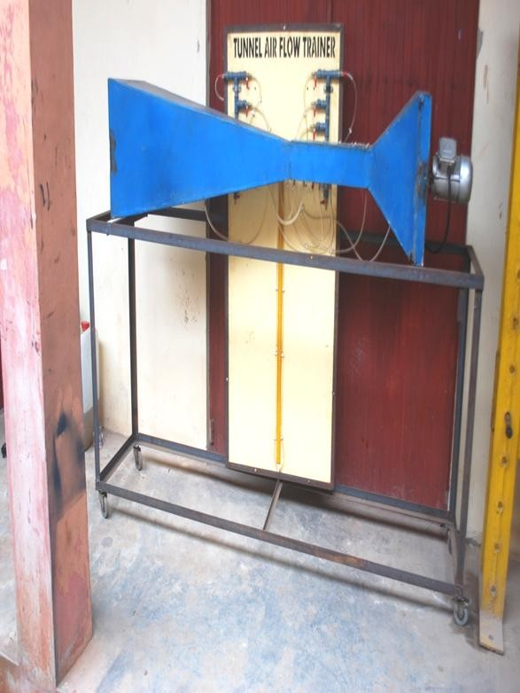

**Figure L-1: The photograph of the prototype venturi air tunnel trainer after completion and commissioning**

## INNOVATION OF PROTOTYPE HAGEN-POISEUILLE DEMONSTRATION TRAINER

**By**

**OGUEJIOFOR George C. ILO Ugochukwu V.,**

**NWOBODO Valentine Department of Industrial & Production Engineering**

**OHALE Paschal E. Nnamdi Azikiwe University**

**UMEMBAMALU, Chinedu J. Awka**

**Department of Chemical Engineering**

**Nnamdi Azikiwe University**

**Awka**

**Correspondences to:**

[**E-mail:oguejioforg@yahoo.com**](mailto:oguejioforg@yahoo.com), **o**[**guejiofor.chiedozie@gmail.com**](mailto:guejiofor.chiedozie@gmail.com)

**Phone:+234(0)8035500882**

## ABSTRACT

An engineering initiative for diminishing the deficit in engineering education equipment in Nigerian Universities was undertaken by innovating an archived equipment. A disused accessory of a hydraulic bench was picked up from the scrap yard and innovated. Are tooling process of replacing the traditional manometer with two-input digital electronic manometer was undertaken. From two pressure tapping points on along straight pipe with a small flow channel/aperture, the tubing process was commenced using a flexible transparent tube. The tubing terminated at the two-input electronic manometer. There sult of the retooling and tubing processes produced the prototype Hagen-Poiseuille demonstration trainer. The enclosed photograph showed the prototype trainer. It has the potential of demonstrating and verifying the liquid flow theory from Hagen-Poiseuille when coupled to a hydraulic bench. It is hoped that the prototype will assist in reducing the foreign exchange pressure for teaching equipment importation into Nigeria as well enhancing engineering accreditation requirements.

Keywords: engineering initiative, disused accessory, retooling process, Hagen-Poiseuille, foreign-exchange pressure, hydraulic bench.

**EQUIPMENT DESCRIPTION**

This equipment was formerly a component of Ebunso’s fluid mechanics equipment until it was transformed into a unit for demonstrating Hagen-Poiseuille’s principle. It consists of

⅜ inch steel pipe of small and uniform cross section, and having a length of about 1.5m.A ⅜ inch ball valve at the exit of the pipe ensures the control of liquid flow through the pipe length. Two pressure tapping points, which situates at the distance of 1.5m from each other are provided on the steel pipe. The pressure tapping points are connected by flexible tubes to the two-input electronic manometer (See Appendix for photograph). The service for this unit is provided by water pumped from the hydraulic bench.

**DEMONSTRATION AND TEACHING CAPABILITY**

The trainer is equipped to demonstrate and practicalise the law/principle of Hagen-Poiseuille in fluid mechanics.

**DEPLOYMENT AND COMMERCIALISATION POTENTIAL**

The unit is deployable in engineering laboratories for engineering student education and training in fluid mechanics.

**POSSIBLE INVESTORS**

Likely investors are the NUC, NBTE, Universities, Polytechnics and Technical Colleges of Education. SEDI and NOTAP could act as catalysts for commercialization and attraction of investors.

**APPENDIX**

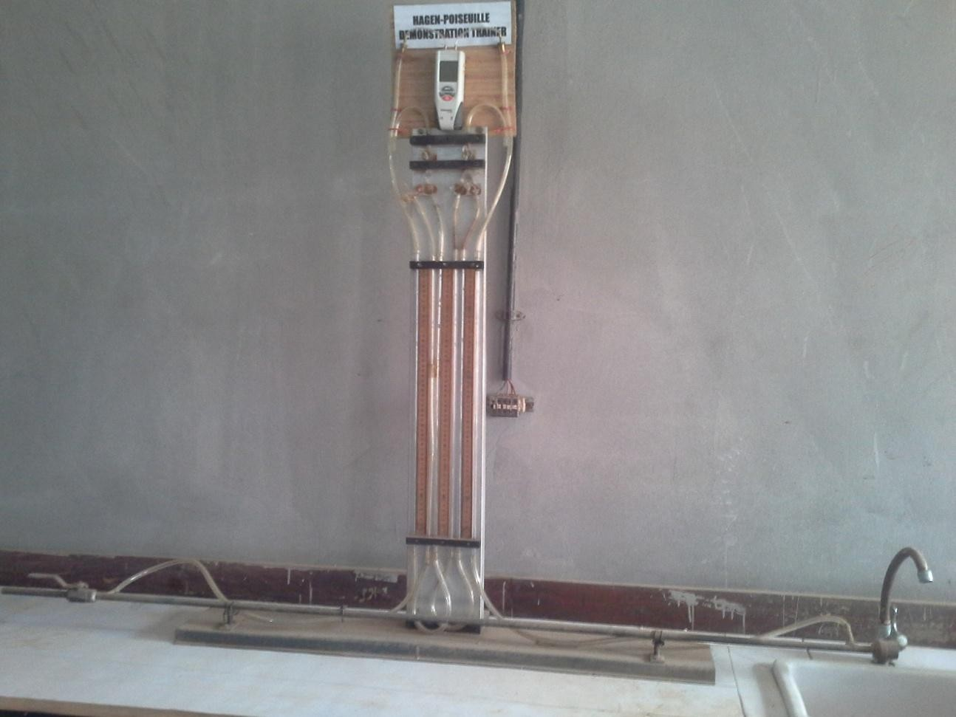

**FigureM-1:The photograph of the prototype Hagen-Poiseuille demonstration trainer.**

**ACKNOWLEDGEMENT**

We acknowledge with gratitude the funding from: personal pockets; students and staff advisers (Menkiti M. C. and Nwokolo S. O.) of NSCHE, UNIZIK, Chapter; DTLC allocations from HoD ChE (Nwabanne J. T.).We also thank our treasurers Emembolu L.N. and Ohale P. E.

**DONATIONS**

**ENGINEERING TEACHING AND RESEARCH EQUIPMENT SYSTEMS AND TRAINERS DONATED FROM PROTOTYPES GALLERY TO CARITAS UNIVERSITY, ENUGU.**

**FLUID MECHANICS AND HEAT TRANSFER TRAINER**

**AND**

**CONSTANT HEAD WATER CIRCULATOR**

**Engineering Teaching and Research Equipment and Trainers, designed, produced and donated to the Department of Chemical Engineering, Caritas University, Enugu.**

**by**

**George Chiedozie OGUEJIOFOR (August 2011).**

**1)FLUID MECHANICS AND HEAT TRANSFER TRAINER**

**EQUIPMENT DESCRIPTION**

Fluid Mechanics and Heat Transfer Trainer (see Figures 1&2) is made up of three major components, namely the fluid mechanics testpipe, the concentric tube heat exchanger and the bare pipe for heat loss experimentation.

a)**Fluid Mechanics Testpipe**

The fluid mechanics testpipe consists of: a horizontally-mounted orifice, a vertically-mounted orifice, a 90-degree elbow and a one-metre straight pipe; all of which are fitted with pressure-tapping points and connected individually to a bank of U-tube manometers (Figures 1 & 2). One end of the fluid mechanics testpipe is connected by a pipe to the centrifugal pump and water tank in series. The other end of the testpipe is connected by flexible tubing to the same water tank, thus ensuring water re-circulation.

b)**Concentric Tube Heat Exchanger**

The concentric tube heat exchanger, sometimes referred to as the tubular heat exchanger (see Figures 1 & 2), is provided with thermo-wells and flow-control valves on the outer pipe to allow for switching to counter-current, or co-current flow sequences in the annulus part of the concentric tube heat exchanger. The heat exchanger is mounted on a testbed steel frame beside the fluid mechanics testpipe. And the inner pipe of the heat exchanger is connected serially by galvanised pipe to the centrifugal pump and water tank, respectively. Mounted inside the water tank are three 1.5kW electric water heaters, with thermostat for maintaining the setpoint temperature inside the water tank. The exit of the tube-side pipelining is connected into the tank, ensuring that the hot water is pumped from the tank, flows through the tube-side of the exchanger and returns back to the tank. The annulus circulation is the cold-phase flow.

c)**The bare pipe testbed**

The bare pipe testbed is fitted with a thermo-well at its extreme point and also mounted parallel to the fluid mechanics testpipe and the concentric tube heat exchanger on the same steel frame(see Figures 1 and 2). The other end of the bare pipe testbed is linked to the exit pipe from the centrifugal pump to complete its pipelining. The thermo-well mounted at the water tank discharge marks the datum for the bare pipe, while the thermo-well fitted at the extreme point of the bare pipe testbed marks the end of bare piping(Figures 1 & 2).

2)**CONSTANT HEAD WATER CIRCULATOR**

**EQUIPMENT DESCRIPTION**

The consists of an overhead tank mounted on top of the steel frame, a ground tank and a centrifugal pump mounted on the base of the steel frame, as Figures 3 & 4 would show. In the overhead tank is a central downcomer pipe fitted in a manner that the height of downcomer pipe is below and height at the edge of the tank. This ensures that the water, delivered by the centrifugal pump, into the overhead tank maintains a constant head, while the overflow water enters the downcomer and returns by gravity to the ground tank. This flow arrangement ensures that while pump re-circulates the water continuously, the water does not overflow the overhead tank to flood the laboratory floor.

The constant head water circulator is an auxiliary/ancillary equipment for the fluid mechanics and heat transfer trainer, referred to as the TRAINER, for short. Heat transfer experiments/practicals involving concentric tube heat exchangers, require a staggering volume of water to execute by students and other trainees. And given the shortages of municipal/township water supply to Nigeria's municipalities, as well as the challenges disturbing mobile water tank services in our universities, the constant head water circulator was designed and constructed. It is simpler and cheaper than designing and producing a cooling tower. Thus the constant head water circulator (Figures 3 and 4) is a water conservation engineering device.

For heat transfer practicals, the water delivery point at the bottom of the overhead tank of the constant head water circulator is connected by flexible hose to inlet socket to the annulus of the concentric tube heat exchanger. See Figures 5 and 6. Depending on experimental title, the connections for co-occurrent and counter-current flow sequences are provided for in the concentric tube heat exchanger. Refer to Figures 5 and 6.

3)**PRACTICAL PEDAGOGIC CAPABILITIES THE OF TRAINER**

The underlisted are the practical capabilities of the Trainer.

a) Heat transfer coefficient as function of temperature driving forces (LMTD model).

b) Heat transfer coefficient as a function dimensionless numbers (Dittus and Boelter correlation).

c) Heat loss to the surroundings from a bare steel pipe.

d) Convective heat transfer coefficients for tube-side flow in a co-current and counter-current flow sequences.

e) Convective heat transfer coefficients for annulus-side flow in co-current and counter-current flow regimes.

f)Comparative evaluation of pressure drop in horizontally-mounted and vertically-mounted orifices.

g) Pressure drop for upward and downward flows through 90-degree elbows.

h) Pressure drop in flow through a linear pipe of uniform cross-section.

4)**SKILLS ACQUIRABLE FROM THE TRAINER EXPERIMENTS**

a) Priming and purging of centrifugal pumps to drive off air.

b)Easing high pressure on centrifugal pump discharge/outlet through opening of the bye-pass pipeline .

c) Flow control and adjustment via control valve.

d) Flow rate measurement with measuring cylinder and time.

e) Pressure measurement from different Hg manometer.

f) Temperature measurement with Hg and electronic thermometers.

5)**KNOWLEDGE ACQUIRABLE FROM THE TRAINER**

a)Computation of LMTD from experimental measurements for co-current and counter-current flow regimes.

b) Calculate of pressure difference from experimental measurements.

c) Computation of heat transfer coefficients from heat balance equation, using personally measured data.

d) Computation of heat transfer coefficients from dimensionless numbers approach(Dittus-Boelter correlation), by employing measurements made by self.

6)**CONCLUSION**

In view of the foregone articulations, the fluid mechanics and heat transfer trainer (THE TRAINER) and the constant head water circulator are hereby donated to the Department of Chemical Engineering, Caritas University, Enugu, for the enhancing practical learning and research in core chemical engineering fundamentals.

Figure 1: Front view of Fluid Mechanics and Heat Transfer Trainer.

Figure 2: Side view of Fluid Mechanics and Heat Transfer Trainer.

Figure 3: Front view of Constant Head Water Circulator.

Figure 4: Side view of Constant Head Water Circulator.

Figure 5: Front view of combined Fluid Mechanics and Heat Transfer Trainer, plus its ancillary Constant Head Water Circulator.

Figure 6: Isometric view of combined Fluid Mechanics and Heat Transfer Trainer, plus its auxiliary Constant Head Water Circulator.

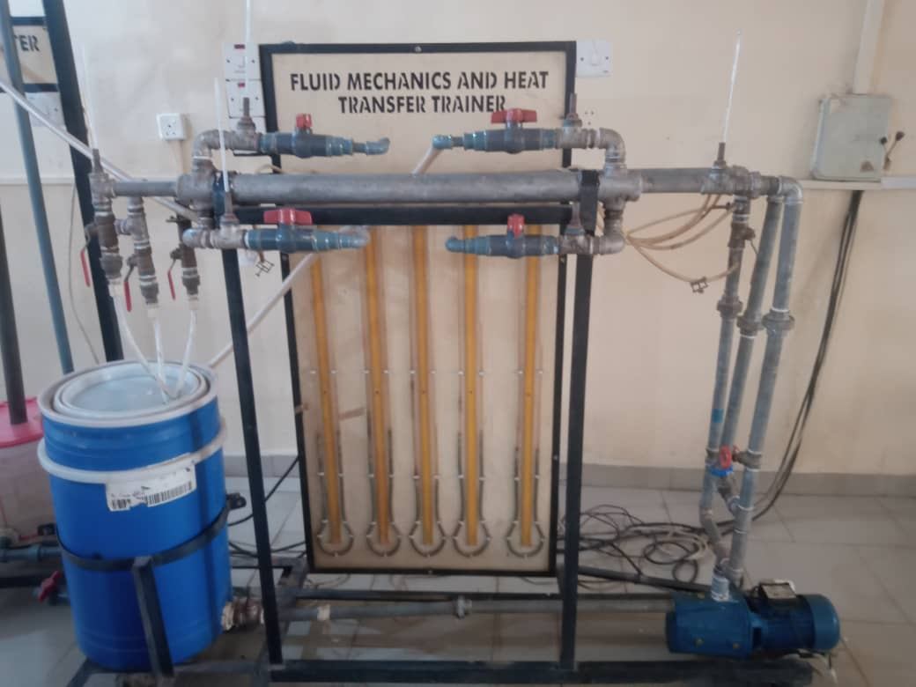

**Figure 1: Front view of Fluid Mechanics and Heat Transfer Trainer**

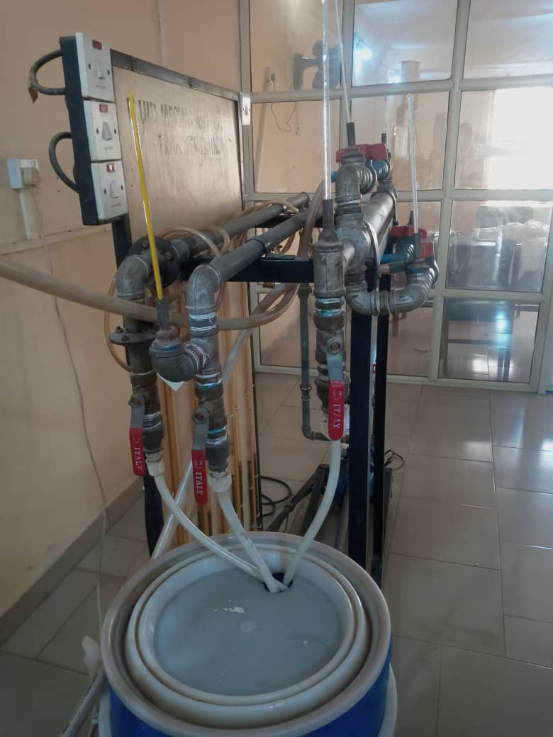

**Figure 2: Side view of Fluid Mechanics and Heat Transfer Trainer**

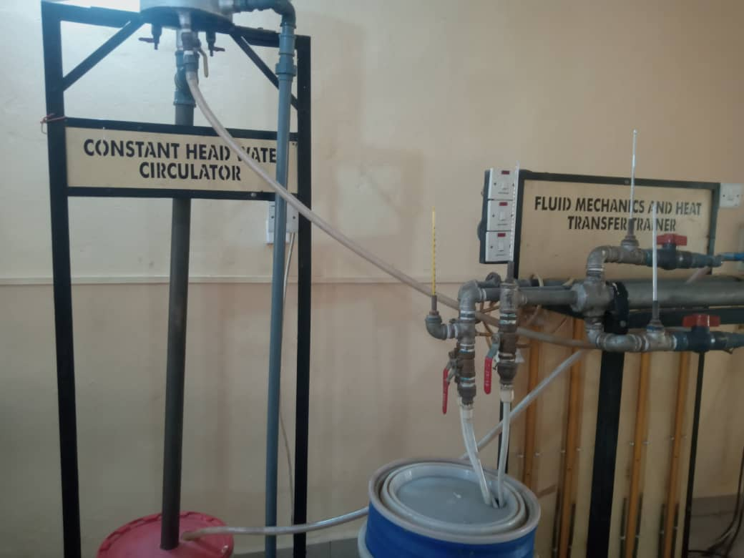

**Figure 3: Front view of Constant Head Water Circulator**

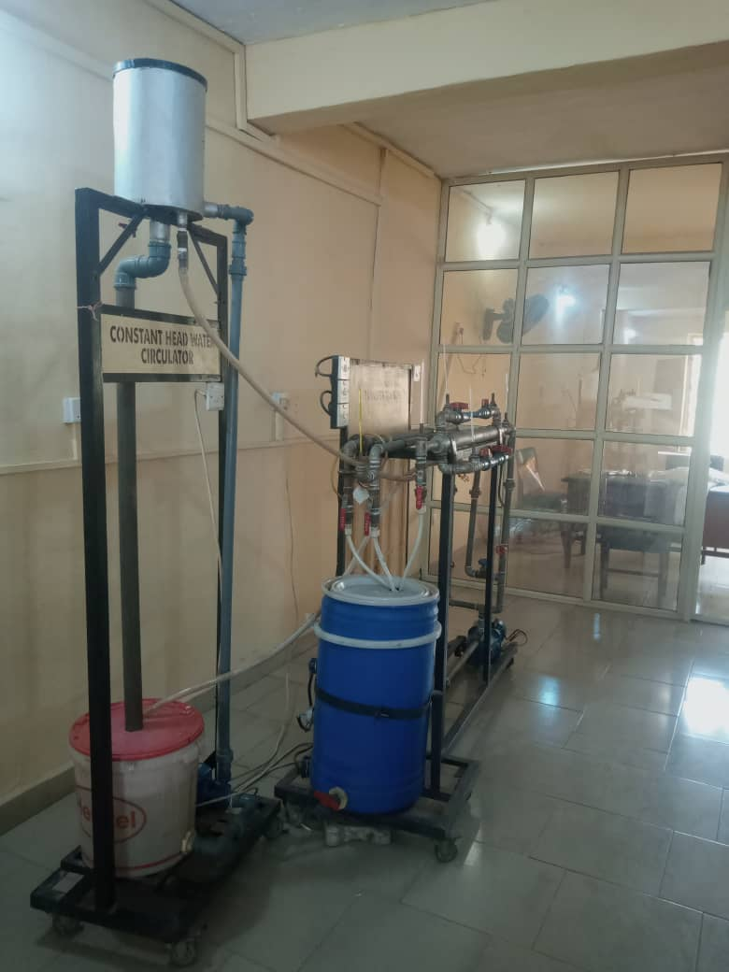

**Figure 4: Side view of Constant Head Water Circulator**

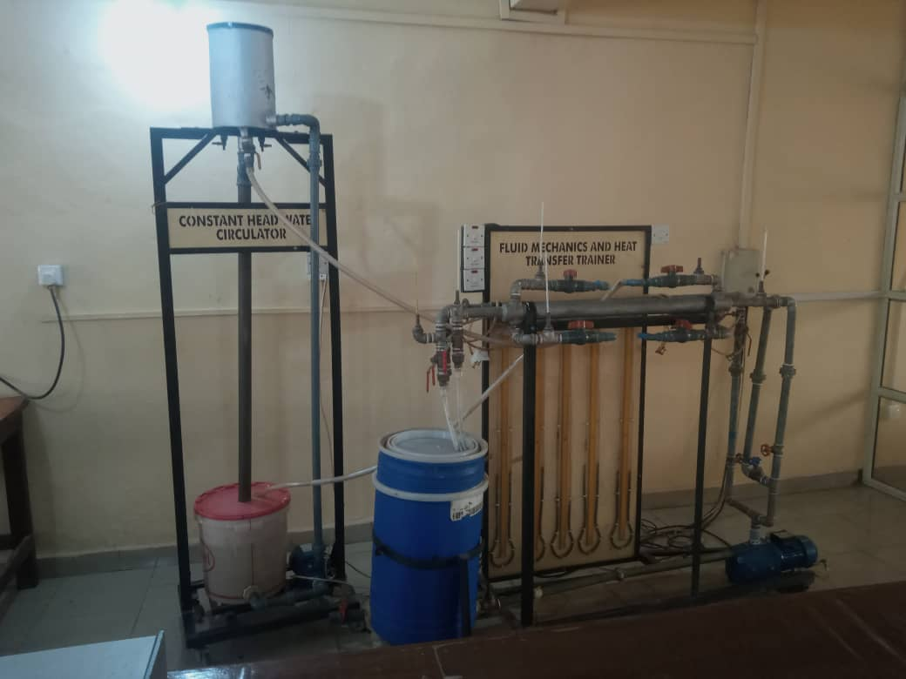

**Figure 5: Front view of combined Fluid Mechanics and Heat Transfer Trainer, plus its ancillary Constant Head Water Circulator.**

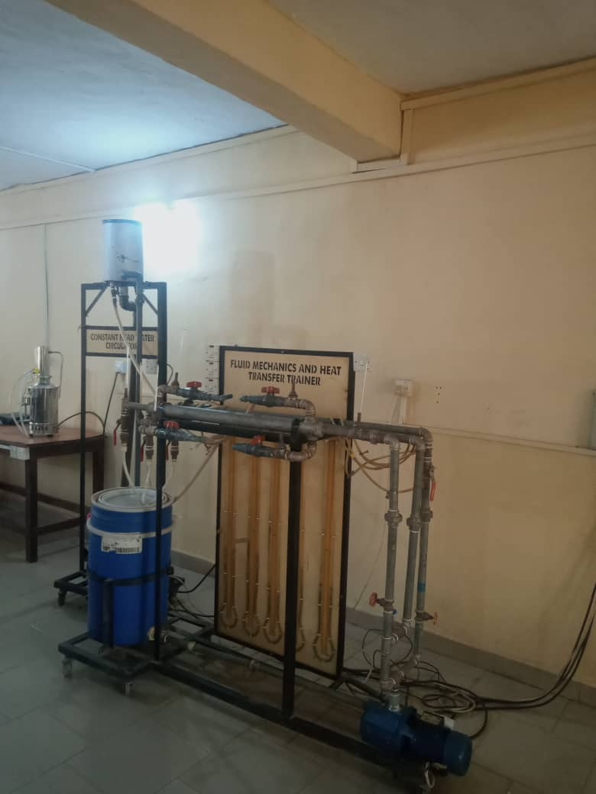

**Figure 6: Isometric view of combined Fluid Mechanics and Heat Transfer Trainer, plus its auxiliary Constant Head Water Circulator.**